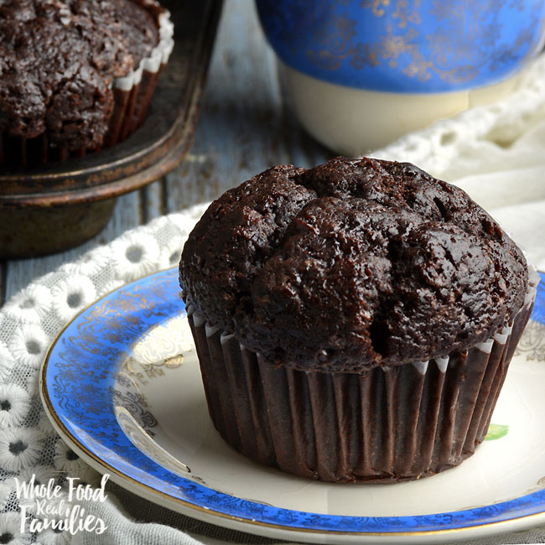
Chocolate muffin
recipe
Ingredients:
- 350g flour
- 600g sugar
- 140g cocoa
- 2¼ tsp baking powder
- 1½ tsp bicarbonate of soda
- 1½ tsp salt
- 3 eggs
- 350ml milk
- 180ml oil
- 2 tsp vanilla
- 120ml hot water

Method:
- Pre-heat the the oven to 160 C.
- Line muffin case.
- Mix all dry ingredients together.
- Add wet ingredients and mix
together.
- Fill muffin cakes two thirds the way up.
- Bake for 15 minutes or until skewer comes clean.
- When ready take out of oven let them cool on a cooling rack and enjoy.

Adapted by: Latishia Agius

