Vanilla and chocolate cupcakes:

Ingredients
Serves: 12
- 2 tablespoons unsweetened cocoa powder
- 1 tablespoon water
- 200g caster sugar
- 110g butter
- 2 eggs
- 2 teaspoons vanilla extract
- 200g plain flour
- 1 3/4 teaspoons baking powder
- 125ml milk

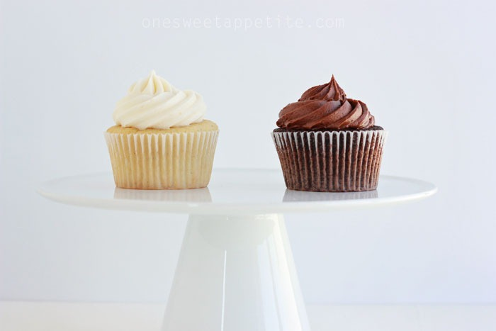

Method:

Prep:20min › Cook:20min › Ready in:40min
- Preheat the oven to 180 C / Gas 4. Grease and flour a cupcake tin, or line with paper cases.
- Stir together the cocoa and water to form a paste. Set aside.
- In a medium bowl, cream together the sugar and butter. Beat in the eggs, one at a time, then stir in the vanilla.
- Combine flour and baking powder, add to the creamed mixture and mix well. Gradually stir in the milk until the mixture is smooth.
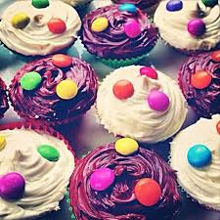
- Spoon half of the cupcake mixture into a second bowl. Stir in the cocoa mixture till well combined. Spoon mixture into the prepared tin, filling cases 3/4 full. Repeat with the vanilla cupcake mixture.
- Bake cupcakes for 20 to 25 minutes. Cupcakes are done when they spring back to the touch. Let cool completely before topping with your favourite icing

