Southern Red Velvet Cake
Adapted by Kaya Cauchi

Ingredients;
- 2 1/2 cups all-purpose flour
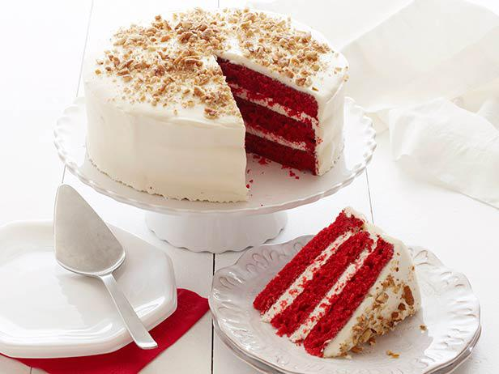
- 1 1/2 cups sugar
- 1 teaspoon baking soda
- 1 teaspoon fine salt
- 1 teaspoon cocoa powder
- 1 1/2 cups vegetable oil
- 1 cup buttermilk, at room temperature
- 2 large eggs, at room temperature
- 2 tablespoons red food colouring
- 1 teaspoon white distilled vinegar
- 1 teaspoon vanilla extract

Directions;
- Preheat the oven to 350 degrees F. Lightly oil and flour three 9 by 1 1/2-inch round cake pans.
- In a large bowl, sift together the flour, sugar, baking soda, salt, and cocoa powder. In another large bowl, whisk together the oil, buttermilk, eggs, food colouring, vinegar, and vanilla.
- Using a standing mixer, mix the dry ingredients into the wet ingredients until just combined and a smooth batter is formed.
- Divide the cake batter evenly among the prepared cake pans. Place the pans in the oven evenly spaced apart. Bake, rotating the pans halfway through the cooking, until the cake pulls away from the side of the pans, and a toothpick inserted in the centre of the cakes comes out clean, about 30 minutes.
- Remove the cakes from the oven and run a knife around the edges to loosen them from the sides of the pans. One at a time, invert the cakes onto a plate and then re-invert them onto a cooling rack, rounded-sides up. Let cool completely.

