Rainbow marble buttercake:

Ingredients:
SPONGE
375g unsalted butter, chopped, at room temperature
2 1⁄4 cups caster sugar
2 tsps vanilla extract
6 eggs, at room temperature
1 1⁄2 cups milk
4 cups self-raising flour
Pink, blue, yellow and green food colouring to tint, and M&M’s and hundreds and thousands to decorate
Buttercream:
200g unsalted butter, chopped, at room temperature
2 cups icing sugar mixture

Method:
Grease a 23cm x 33cm (6cm deep) roasting pan. Line base and sides with baking paper, extending paper 3cm above pan.
Beat butter, sugar and vanilla in a small bowl of an electric mixer until fluffy. Transfer to a large bowl of an electric mixer. Beat in eggs one at a time until combined. Add milk and sifted flour, in two batches, stirring until combined.
Divide mixture equally among four bowls. Tint each with a different colouring.
Spoon mixtures into prepared pan, alternating between colours. Using a skewer, gently swirl through for a marbled effect.
Cook in a moderately slow oven (160C) for about 50 minutes, or until a skewer inserted into centre comes out clean. Remove from oven. Stand in pan 20 minutes. Transfer to a wire rack to cool.
To make buttercream, beat butter in a clean, small bowl of electric mixer until fluffy. Gradually beat in sugar, 1⁄2 cup at a time, until combined.
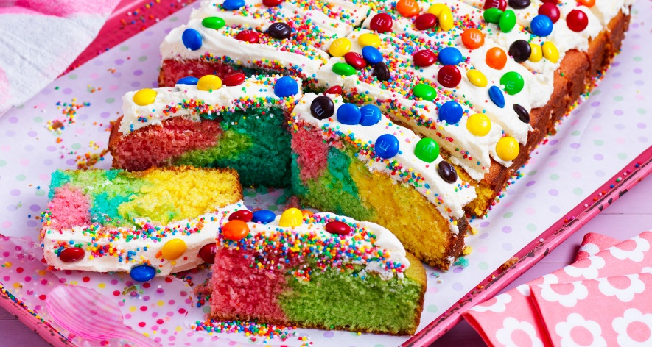
Spread buttercream over cake. Decorate with M&M’s and hundreds and thousands. Cut into 24 slices.

