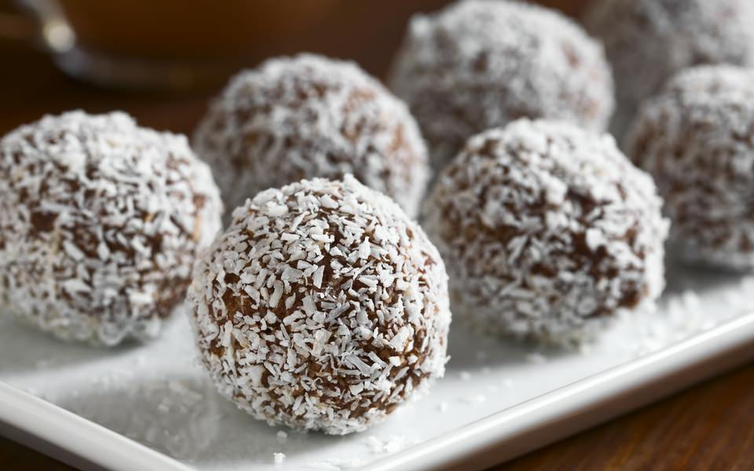
Mama’s Coconut Balls
Easy and Delicious !

This serves about 60-65 coconut balls, depending on the size

Ingredients:
3 packets of plain biscuits ( any kind )
2 full table spoons of Cocoa
2 cans of condensed milk ( light or normal )
Approximately 1 packet of coconut
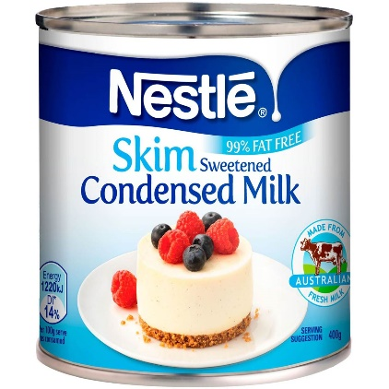

Method:
- First, crush the biscuits in a big, round bowl.
- Add the cocoa in the bowl .
- Pour the condensed milk in the bowl .
- Mix the biscuits, cocoa and condensed milk.
- Form the mixture in balls not too big or small.
- Roll the balls in the coconut.
- Let to cool for about 10 minutes.
- Serve neatly on a plate .
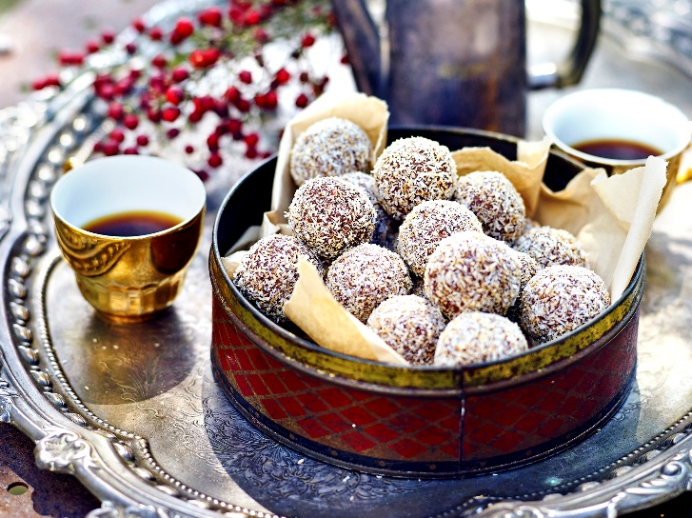

Enjoy !

