Carrot cake
Serves for 10-12
- Ingredients:
- 1 cup (2 sticks) unsalted butter, softened, plus extra for greasing
- 1 cup plus 2 tablespoons light brown sugar
- 4 eggs
- Finely grated zest of 1 orange
- 1 ⅓cups plus 1 tablespoon self-rising flour
- 1 tablespoon baking powder
- 1 cup ground hazelnut
- 4 drained pieces stem ginger in syrup (about 2 ½ oz ), chopped
- 2 ¾ cups finely grated carrots

Method:
- Preheat the oven to 350 °F. Grease and line an 8-inch round cake pan.
- In a large bowl, beat the butter, sugar, eggs, orange zest, flour, baking powder, ground hazelnuts, and ginger together until smooth and creamy. Stir in the carrots and raisins until evenly combined.
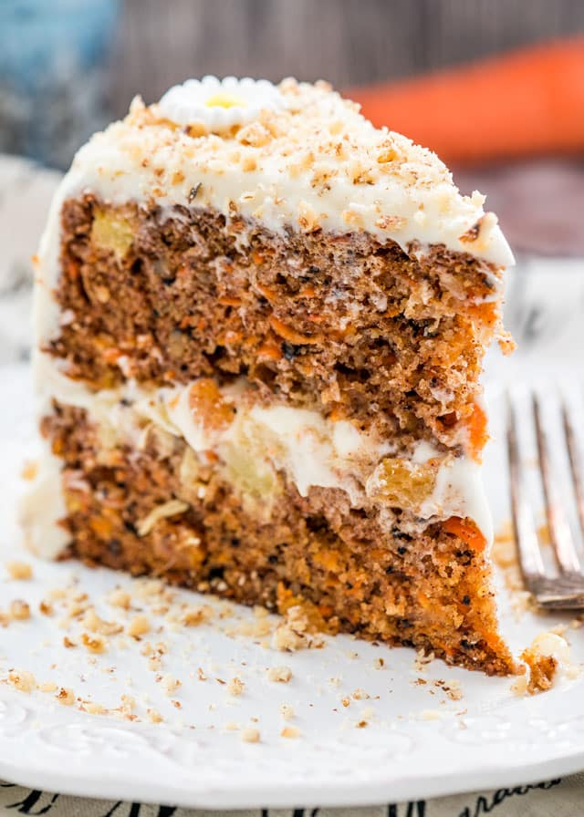
- Turn the batter into the prepared pan and level the surface. Bake in the oven for about 1 hour, or until just firm and a toothpick inserted into the centre comes out clean. Transfer to a wire rack to cool.
