Brownies
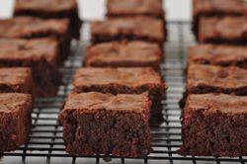
Ingredients:
- 150gr chocolate
- 113gr margarine
- 2tbsp cocoa powder
- 200gr sugar
- 1tsp vanilla essence
- 3 large eggs
- 95gr all purpose flour
- 1/4tsp salt
- 125gr choc chips
Method:
Preheat oven to 350 degrees F (180 degrees C) and place the rack in the center of the oven. Butter (or spray with a nonstick cooking spray) an 8 inch (20 cm) square pan, and line the bottom of the pan with parchment or wax paper.
Melt the chocolate and butter in a large stainless steel bowl placed over a saucepan of simmering water. Remove from heat and stir in the cocoa powder and sugar. Next, whisk in the vanilla extract and eggs, one at a time, beating well after each addition. Finally, stir in the flour, salt and chocolate chips (if using).
Pour into the prepared pan and bake for about 25-30 minutes, or until a toothpick inserted in the center comes out with a little batter and a few moist clumps clinging to it. Do not over bake. Remove from oven and let cool on a wire rack. Serve at room temperature or chilled. These freeze very well.
Adapted By: Phoebe Grech Senior 2

